1. HTML Screenshot

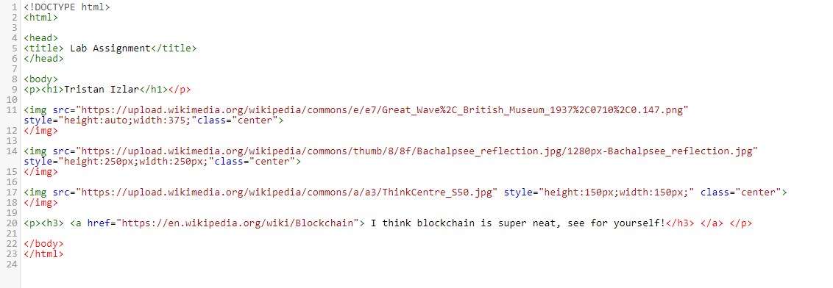

1. CSS Screen Shot

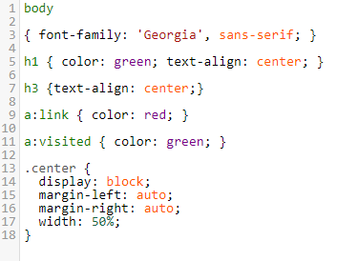

1. Webpage screenshot (neither link provided allowed me to attach a hosted link to the site, but will include a downloaded .html link in the assignment comments.

